MANSFIELD DISTRICT COUNCIL
(PROPOSED) CIVIL ENFORCEMENT OFF-STREET PARKING PLACES
ORDER 2021
Mansfield District Council (hereinafter called “the Council”) in exercise of its powers under Sections 32, 35 and Part IV of Schedule 9 of the Road Traffic Regulation Act 1984, as amended (“the 1984 Act”) and under the Traffic Management Act 2004 as amended (“the 2004 Act”) and of all other enabling powers, with the consent of the Nottinghamshire County Council in accordance with section 39(3) of the 1984 Act and after consultation with the Chief Constable of Nottinghamshire Police Constabulary in accordance with Part III of Schedule 9 to the 1984 Act hereby makes the following Order:
PART I
GENERAL
Commencement and Citation
1. This Order shall come into operation on the 1ST November 2021 and may be cited as the Mansfield District Council Civil Enforcement Off-Street Parking Places Order 2021. The Mansfield District Council Civil Enforcement Off-Street Parking Places Order 2021 Charges and Plans (“the Charges” and “the Plans”) are incorporated into this Order.
Interpretation
2. In this Order, except where the context otherwise requires, the following expressions have the meanings respectively assigned to them:
“Bank Holiday” has the same meaning as described in the Banking and Financial dealings Act 1971. The first Monday of May shall be treated as if it were a Bank Holiday for the purposes of this Order.
“Civil Enforcement Officer” or “Parking Attendant” means a person authorised by or on behalf of the Council to supervise the Parking Places and enforce the restrictions imposed and the contraventions created by this Order.
“Charging Days”, means those days other than Christmas Day and Easter Sunday, which are as specified at each Parking Place and in the Schedule to this Order.
“Charging Hours”, means the period as specified at each Parking Place on all Charging Days and specified in the Schedule to this Order or as amended by Notice of Variation
“Council” means Mansfield District Council.
"Disabled Persons' Badge" means a badge issued by any Local Authority in accordance with the provisions of the Local Authorities’ Traffic Orders Exemptions for Disabled Persons (England) Regulations 2000 or a badge having effect under those regulations as if it were a Disabled Person's Badge;
“Driver” in relation to a Parking Place means the person driving the Vehicle at the time it was left in the Parking Place.
“Electric Vehicle” means an Electric Vehicle or a plugin hybrid Vehicle that is powered entirely or partially by electricity and is capable of being charged from an Electric Charging Point or other external electric power source. The Electric Vehicle must be licensed as private or private/light goods and does not exceed 2500kg in weight or 2 metres in height.
“Electric Charging Point” means apparatus installed within a Parking Place to facilitate the recharging of an Electric Vehicle by way of connection of a power lead from an Electric Charging Point
“Electric Vehicle Parking Bays” means any Parking Bay which has been designated or is at the Council’s discretion hereafter designed for use by Electric Vehicles in order to recharge by using the Electric Charging Point adjacent to the Parking Bay designed for such use. An Electric Vehicle Parking Bay shall be defined as designated for such use. An Electric Vehicle Parking Bay shall be defined for such use by tarmac line markings and or symbols and signage adjacent to the Electric Vehicle Parking Bay indicating the Parking Bay is designated for the sole use of Electric Vehicles only whilst recharging using the Electric Charging Point.
“Electronic Payment” means payment has been made electronically to the Council or its agents via the use of a mobile device in the manner described on signs located at or near the Parking Place where this facility is made available.
“Electronic Ticket” means a cashless parking payment method of charges for use in a Parking Place where facilities at that Parking Place allow payment by telephone or electronic means, allowing vehicles of such classes, in such positions, on such days, during such hours and for such period as are specified in the Schedule of Parking Places to be parked for the period of time for which the Electronic Payment has been made.
“Expiry Time” is the time indicated on the Pay and Display Ticket, Voucher or Free Ticket and is the time by which the parking period for which the parking ticket, Voucher or Electronic Payment period has expired.
“Free Period” means a period of parking for which a Voucher must be obtained and there is nil charge as displayed on site and within the Schedule of Parking Places.
“Goods Vehicle” has the same meaning as that ascribed to it in Section 192 of the Road Traffic Act 1988 (RTA 1988).
“Loading Bay” means an area of a Parking Place, which is provided for the temporary parking of a Vehicle of a class specified and indicated by markings on the surface of the Parking Place or signed or otherwise indicated by signs in the Parking Place to undertake Loading and Unloading of Goods.
“Loading/Unloading” refers to when a Vehicle is parked wholly in a Loading Bay or in a Parking Place or Parking Bay marked for that designated purpose on site, for the purpose of delivering or collecting goods or merchandise or loading or unloading the Vehicle at premises adjacent to the Loading Bay, Parking Place or Parking Bay and the Vehicle does not park for more than twenty minutes or such longer period as a duly authorised officer of the Council may authorise.
“Motorcycle” refers to a solo Motorcycle only and excludes any motorcycle which has a side-car or trailer, or which has more than two wheels.
“Owner” in relation to a Vehicle means the person who is recorded as the registered keeper by the Driver and Vehicle Licensing Agency on the date on which the Vehicle was left in the Parking Place in question.
“Parking Bay” means an area of a Parking Place , which is provided for the leaving of a Vehicle of a class specified and indicated by markings on the surface of the Parking Place or signed or otherwise indicated by signs in the Parking Place .
“Parking Permit” means a season ticket, contract permit, business permit, employee permit, resident’s permit or other Parking Permit of a type and design issued by the Council.
"Parking Place" means the whole and every part of the areas of land shown on the Plans and provided by the Council pursuant to Section 32(1) of the 1984 Act for the purpose of Vehicle parking and not closed (in part or in whole) by a notice, sign or barrier, erected or displayed thereon by authority of the Council in accordance with Article 12 of this Order.
“Pay and Display” means a type of Parking Place whereupon parking the Vehicle in a Parking Bay and prior to leaving the Parking Place a Pay and Display ticket or Electronic Ticket must be purchased or a Voucher must be obtained in accordance with the scale of charges advertised at that Parking Place and in the Schedule to this Order as amended from time to time, as described in Article 23 of this Order.
“Pay and Display Ticket” means a ticket issued by a Ticket Machine located in the Parking Place in which the Vehicle has been left or issued by a person nominated by the Council purchased in accordance with Article 23 of this Order on payment of a charge and valid for a parking period as advertised at that Parking Place and in the Schedule to this Order as amended from time to time. The Pay and Display Ticket must be displayed on the Vehicle in the Relevant Position.
“Pay on Foot/Pay on Exit”: A Parking Place where an entry ticket is taken at the entry barrier to access the Parking Place. Prior to leaving the Parking Place, this Ticket is then inserted in to a Ticket Machine located in the Parking Place and the correct payment in accordance with scale of charges advertised at that Parking Place and specified in the Schedule to this Order as amended from time to time for time parked in the Parking Place is made. The Ticket Machine produces an exit ticket which is then used to raise the barrier on exit.
“Penalty Charge” means the charge set by the Council under Section 77 of Part 6 and Schedule 9 of the 2004 Act which is to be paid to the Council following the issue of a Penalty Charge Notice and within the period notified on the Penalty Charge Notice, from the date of issue of that notice;
“Penalty Charge Notice” means a notice issued by or served by a Civil Enforcement Officer pursuant to the provisions of ‘The Civil Enforcement of Parking Contraventions (England) General Regulations 2007;
“Plans” means the plans annexed to this Order and numbered OPO2021/100, OPO2021/101, OPO2021/102, OPO2021/103, OPO2021/10 to OPO2021/18 and OPO2021/20 to OPO2021/22 inclusive which identify the Parking Places affected by this Order;
“Public Holiday” means Christmas Day, Good Friday and any other day designated by the Government as a public holiday;
“Relevant Position” means
(a) in respect of a Vehicle displaying a valid Disabled Person’s Badge -
(i) in the case of a Vehicle fitted with a dashboard or fascia panel, the badge is exhibited thereon so that Part 1 (the front of the badge), is legible from outside the Vehicle; or
(ii) in the case of a Vehicle not fitted with a dashboard or fascia panel, the badge is exhibited in a conspicuous position on the Vehicle so that Part 1 of the badge is legible from outside the Vehicle
(b) In respect of a Vehicle displaying a Pay and Display Ticket, Voucher, Free Ticket or Parking Permit -
(i) the ticket or permit is exhibited on the inside surface of the windscreen or in a clearly visible position so that it is facing forwards and can be easily seen and read, whereby the Expiry Time, date of purchase and serial number should be visible from the front or side of the Vehicle; or
(ii) in the case of a Vehicle that is not fitted with a transparent windscreen, the ticket or permit is exhibited on the front of the Vehicle facing forwards and clearly visible, whereby the Expiry Time, date of purchase and serial number should be visible.
(c) In respect of a Vehicle displaying a Hackney Carriage Plate –
(i) The plate must be affixed to the Vehicle in accordance with the instructions given within the licence as issued by Mansfield District Council.
“Schedule of Parking” means a schedule of Parking Places, locations, times of use of the said Parking Places, parking tariffs and charges including Free Periods (if any) attached to this order as any be amended or varied from time to time.
“Specified Proportion” means such proportion, applicable to all cases where a Penalty Charge Notice has been issued, as may be determined by the Local Authorities acting through the Joint Committee of the National Parking Adjudication Service and any such successor organisation carrying out the same function
“Ticket Machine” means an apparatus of a type and design approved by the appropriate Minister for the purpose of this Order, being apparatus designed to indicate the time by a clock and to issue Parking Tickets which show either
- a payment has been made of an amount or for a period specified thereon and which specify the date and, either the time of such payment, or the time at which the Vehicle must leave the Parking Place ;
Or
- a Voucher has been obtained for a period specified thereof and which specify the date and, either the time the Voucher was obtained, or the time at which the Vehicle must leave the Parking Place.
“Vehicle” means any motorcar, Motorcycle or other mechanically propelled automobile, licensed as private or private/light goods and not exceeding 2500kg in weight or 2 metres in height;
“Voucher” means a parking device as defined by the Road Trafiic Regulation Act 1984 Section 35 (3B) and for the purpose of this Order is a parking ticket obtained for a Free Period issued by either a Ticket Machine located in the Parking Place in which the Vehicle has been left as an Electronic Ticket specifically for the Parking Place in which the Vehicle has been left or as issued by a person authorised by the Council. The Voucher will be valid for a period of time as specified at that Parking Place and within the Schedule of Parking Places and must be either available for the Council to verify as an Electronic Ticket or displayed in the Relevant Position.
3. Except where the context requires otherwise, any reference in this Order to a numbered Article shall be construed as a reference to the Article bearing that number in this Order and any reference to a plan is a reference to the Plans incorporated into this Order.
4. Any reference in this Order to any enactment shall be construed as a reference to that enactment as amended, applied, consolidated, re-enacted by or as having effect by virtue of any subsequent enactment. Unless the context otherwise requires words denoting the singular shall include the plural and vice versa and words denoting persons shall include either gender, bodies corporate, unincorporated associations and partnerships
5. The Interpretation Act 1978 shall apply for the interpretation of this Order.
PART II
DESIGNATION AND USE OF PARKING PLACES
Designation
6. Each area of land or buildings as shown coloured green on the Plans, may be used, subject to the provisions of this Order, as a place to leave Vehicles of such classes, in such positions, on such days, during such hours, for such period and on payment of such charges as are advertised at each Parking Place and as specified in the Schedule to this Order as amended from time to time.
Class and position of Vehicle
7. Where by notice at a Parking Place , a Parking Place is described as available for Vehicles of a specified class or Vehicles to be left in a specified location, no person shall permit a Vehicle to park in that Parking Place or as the case maybe in any Parking Bay within the Parking Place ,
(i) Unless it is of the specified class;
(ii) Where it exceeds the maximum height or weight specified in that Parking Place; except where a vehicle has been modified to accommodate a disability wheelchair or a mobility scooter and is parked in accordance with Article 7 (iii) and Article 8 of this Order
(iii) that is parked beyond the Parking Bay markings; or
(iv) in a position other than that specified.
Disabled person’s parking bays
8. No person shall cause or permit a Vehicle to park in a Parking Bay marked for disabled persons unless the Vehicle displays a valid Disabled Person’s Badge in the Relevant Position. Where required the Vehicle shall also display the Disabled Badge clock in accordance with local regulations. A disabled persons Parking Bay shall be defined as designated for such use by tarmac line markings and or symbols indicating the Parking Bay is designated for use by a person holding a valid Disabled Persons Badge (blue or green badge)
Taxi Ranks
9. No person shall cause or permit a Vehicle to park in a Parking Bay marked for taxis unless the Vehicle displays a valid Hackney Carriage plate, issued by Mansfield District Council, in the Relevant Position.
Loading and Unloading bays
10. No person shall cause or permit a Vehicle to park in a Parking Bay marked as a Loading Bay unless the Vehicle is being used for the purpose of Loading or Unloading.
Motorcycle parking bays
11. No person shall cause or permit a Vehicle to park in a Parking Bay marked for Motorcycles unless the Vehicle is a Motorcycle.
Power to close or suspend Parking Places
12 Nothing in this Order shall prevent the Council by notice, sign or barrier displayed in a Parking Place:
(i) From closing a Parking Place or any part thereof for any period; and/or
(ii) from suspending the use of a Parking Place or any part thereof for any period; and/or from setting aside a Parking Place or any part or parts thereof on all days or on certain days or during certain parts of days for use only by particular Vehicles or organisations.
13. Any person suspending the use of a Parking Place or any part thereof in accordance with the provisions of Article 12 shall thereupon place or cause to be placed in or adjacent to that Parking Place or that part thereof a notice or traffic sign indicating that the use of that Parking Place or that part thereof is suspended and that parking by Vehicles is prohibited.
14. No person shall cause or permit a Vehicle to be left in a Parking Place or any part thereof during such periods that the use of that Parking Place or that part thereof is closed or suspended or during such period as there is in or adjacent thereto a notice or traffic sign placed by or on behalf of the Council in pursuance of Article 13.

Use of Parking Place
15. No person shall while a Vehicle is in a Parking Place use the Parking Place for any purpose other than parking the Vehicle, boarding or alighting from the Vehicle or taking articles out of or into the Vehicle or placing articles into the vehicle immediately prior to leaving or moving the Vehicle or Loading/Unloading where permitted under this Order and in particular but without prejudice to the generality of the foregoing provisions of this Article no person shall:
(i) Carry out any work of construction overhauling cleaning or repair in respect of the Vehicle except as may be necessary to enable the Vehicle to be moved from the Parking Place;
(ii) Use the Parking Place to make deliveries except where authorisation is granted by an authorised officer of the Council.
(iii) Use a Vehicle while it is in a Parking Place in connection with the sale of any article (including the Vehicle itself) to persons in or near the Parking Place or in connection with the selling or offering for hire of his or another person’s skills or services in any capacity, unless with the express written permission of the Council;
(ivi) Except with the permission of an authorised officer of the Council or Civil Enforcement Officer drive any Vehicle in a Parking Place other than for the purpose of leaving that Vehicle in the Parking Place or for the purpose of departing from the Parking Place in accordance with the provisions of this Order.
Maximum Period of Stay
16. Where a Parking Place is described by a notice displayed within it or in the Schedule to this Order as amended from time to time as being available on specified days, during specified hours or for a maximum period of stay, no person shall permit a Vehicle to park in that Parking Place on any day, during such hours or for any period other than or longer than those specified.
Period of no return
17. Where by notice on site or in the Schedule to this Order as amended from time to time a Parking Place is described as having a period within which a Vehicle may not return, no person shall permit a Vehicle to park in that Parking Place on any day, during such period.
Parked with engine running
18. The driver of a motor Vehicle using a Parking Place shall stop the engine as soon as the Vehicle is in the Parking Bay and shall not start the engine except when about to change the position of the Vehicle in or to depart from the Parking Place;

Parked causing an obstruction
19. The driver of a motor Vehicle using a Parking Place shall not park the Vehicle in such a manner or place where it causes an obstruction to any other users of the Parking Place.
Electric vehicle parking bays
20. No person shall cause or permit a Vehicle to park in an Electric Vehicle Parking Bay within a Parking Place or wait for any period in a Parking Bay designated for such use unless the Vehicle is an Electric Vehicle connected by electric power lead to an adjacent Electric Charging Point consuming an electrical charge and is being charged or recharged continually throughout the period within which the Electric Vehicle is parked or waiting within that Parking Bay. Only Electric Vehicles shall be permitted to park in an Electric Vehicle Parking Bay.
PART III
CHARGES FOR PARKING
Payment
21. The driver of a Vehicle using a Pay and Display Parking Place shall upon parking the Vehicle in the Parking Place purchase or obtain a Pay and Display Ticket at the appropriate charge (if any) or make a payment by Electronic Payment method at the level of charge in accordance with the scale of current charges as specified on site and specified in the Schedule. Where a Free Period of parking is specified on site and specified in the Schedule for which a free parking ticket is required, a Voucher may be obtained.
Pay on Exit / Pay on Foot Parking Places
22. The driver of a Vehicle using a Pay on Exit / Pay on Foot Parking Place shall, upon arriving at the Parking Place, take a Parking Ticket from the Ticket Machine to establish time of entry at the Parking Place and shall on return to the Vehicle prior to exit, pay the appropriate fee at the Pay on Foot machines or pay the attendant on duty, or a person nominated by the Council at the exit point, as the case may be a parking fee at the level of charge and for the period required in accordance with the scale of charges as advertised on site and in the Schedule to this Order as amended from time to time.
Pay and Display Parking Places
23. The driver of a Vehicle using a Pay and Display Parking Place, or any Parking Bay within the Parking Place, shall upon parking the Vehicle in a Parking Bay, and prior to leaving the Parking Place, purchase a Pay and Display Ticket or obtain a Pay and Display Ticket at the appropriate level of charge (if any) or make an Electronic Payment, at the level of charge and for the period required in accordance with the scale of charges as advertised at that Parking Place and in the Schedule to this Order as amended from time to time.
Means of payment
24. The charges (if any) referred to in Articles 21, 22 and 23 shall be payable in the manner, as advertised at that Parking Place, or by payment to a person authorised by the Council.
Display of Parking Ticket or Voucher
25. (a) Once a Vehicle has been parked within a Pay and Display Parking Place the driver of the Vehicle shall:
(i) ensure that a valid Pay and Display Ticket or Voucher has been obtained and is displayed at all times the Vehicle is parked, to cover the entire period that the Vehicle is parked in the Parking Place, and
(ii) Display the Pay and Display Ticket or Voucher issued at that Parking Place in the Relevant Position on the Vehicle in respect of which it was issued.
(b) Article 25 (a) does not apply if Payment is made via Electronic Payment.
Validity of Pay and Display Tickets
26. A Pay and Display Ticket is not transferable from one Vehicle to another and on transfer the ticket ceases to be valid.
27. A Pay and Display Ticket is valid only in the Parking Place in which it was issued. This is defined by the reference code of the Ticket Machine located in that Parking Place printed on the Pay and Display Ticket.
Expiry of parking period
28. The expiry of the period for which a charge specified for the use of a Parking Place has been paid (as advertised at the Parking Place and specified in the Schedule to this Order as amended from time to time) shall be
(i) Where there is exhibited on the Vehicle a Pay and Display Ticket and the expiry date and time printed on the Pay and Display Ticket has passed, or
(ii) Where an alternative approved method of payment has been used, when the period for which payment has been made and recorded has been exceeded.
No Pay and Display Ticket or Voucher displayed
29. If at any time while a Vehicle is left in a Parking Place no Pay and Display Ticket or Voucher is displayed on that Vehicle in the Relevant Position and in accordance with the provisions of Article 25, it shall be deemed that the charge (if any) has not been paid unless an Electronic Ticket has been purchased that is valid for the Parking Place..
30. If at the time when a Vehicle is left during the Charging Hours in a Pay and Display Parking Place and on the nearest Ticket Machine in that Parking Place there is a notice placed by any person duly authorised by the Council indicating that the said Ticket Machine is out of order then a ticket shall be obtained from another Ticket Machine within the same Parking Place (where another Ticket Machine is so provided) or from a person nominated by the Council or via Electronic Payment. Otherwise Article 31 shall prevail where there is no Ticket Machine or all Ticket Machines are out of order, (whether signed as such or not) and if there is no person authorised by the Council for the purpose of issuing a ticket.
31. Where no valid Pay and Display Ticket, Voucher or Electronic Ticket can be obtained and/or displayed pursuant to the circumstances described in Article 30, Vehicles may be left in a Parking Place but may not be left for longer than the maximum period of parking in that Parking Place advertised at that Parking Place
Parking Permits
32. Parking Permits are available from the Council at the appropriate fee, for a Vehicle of a specific class and for a specific Parking Place subject to conditions determined by the Council.
33. The driver shall abide by the terms stipulated by the Council for the use of the Parking Permit.
34. A Parking Permit is only valid in the Parking Place in respect of which it was issued and up to the date of expiry shown on the Parking Permit.
35. A Parking Permit remains the property of the Council and must be surrendered on request. In such instances where a refund fee is appropriate this will be provided in accordance with the Council’s policies.
Display of Parking Permit
36. The driver of the Vehicle shall display the Parking Permit in the Relevant Position on the Vehicle in respect of which it was issued at all times during which the Vehicle is left in the Parking Place . Electronic permits and decrementing pre-paid cards are exempt from the need to display in a Pay on Foot or Pay on Exit car park.
Replacement Parking Permits
37. Damaged or lost Parking Permits will be replaced on application to the Council and on payment of an administration fee. The damaged or lost Parking Permit will then become immediately invalid.
Surrender of Parking Permit
38. The holder of an annual Parking Permit shall on surrendering the Parking Permit be entitled to a refund based upon the number of complete months remaining un-expired from the beginning of the calendar month following the date on which the Council receives the surrendered Parking Permit. The refund will be one twelfth of the annual rate for each un-expired calendar month less an administration fee. The Council may accept the transfer of a Parking Permit to a new Vehicle on the surrender of the existing Parking Permit to the Council subject to the relevant administration fee and subject to the procedure stated in the conditions of holding such a permit.
Restriction on removal
39. When a Pay and Display Ticket, Voucher or Parking Permit has been exhibited on a Vehicle in the relevant position no person shall remove the Pay and Display Ticket or Parking Permit from the Vehicle until the Vehicle is removed from the Parking Place.
PART IV
EXEMPTIONS FROM DAILY CHARGES
40. No daily charge shall be payable in respect of;
(i) a Vehicle which displays in the relevant position a valid Disabled Person’s Badge and correctly set time clock in accordance with Article 8. or
(ii) a Motorcycle which is left in a Parking Bay specified for such Vehicles (if any) where such exemption is advertised as applying at the site,; or
(iii) a Vehicle left displaying in a Relevant Position a valid Parking Permit valid for that Parking Place.
(iv) a vehicle left in a Relevant Position displaying a Voucher valid for that Parking Place in accordance with Article 26 and used in association with a Free Period
Absence of ticket machine
41. If at the time when a Vehicle is left in a Parking Place during the Charging Hours there is no Ticket Machine at the Parking Place and payment cannot be made via Electronic Payment, or all the Ticket Machines at that Parking Place carry notices placed upon them by a person duly authorised by the Council indicating that they are out of order, the driver of that Vehicle shall be exempt from purchasing a Pay and Display Ticket or Voucher. Otherwise Article 31 shall prevail where there is no Ticket Machine or a ticket cannot be purchased or all Ticket Machines are out of order whether signed as such or not.

PART V
RELOCATION AND REMOVAL OF VEHICLES
Emergencies
42. A Civil Enforcement Officer, a person authorised by the Council or a Police Constable in uniform may, using such measures as are appropriate, move or cause to be moved in the case of an emergency to any place he/she thinks fit, any Vehicle left in a Parking Place .
Safe keeping
43. Any person removing a Vehicle from a Parking Place under Article 42 shall make such arrangements as may be reasonably necessary to provide for the safe keeping of the Vehicle

PART VI
LIABILITIES / PENALTIES
Liability
44. The Council accepts no liability for the loss or damage to Vehicles or other property left in any of the Parking Places to which this Order applies.
Wilful damage
45. Any person who with intent to defraud interferes with the Ticket Machine or operates or attempts to operate any Ticket Machine by the insertion of objects other than undamaged and unaltered coins of legal tender and of the appropriate denomination, or other approved method of payment, shall be liable to prosecution.
PART VII
CONTRAVENTION AND PENALTY CHARGE
Contravention
46. If a Vehicle is parked in a Parking Place without complying with the requirements of this Order, a contravention shall have occurred and a Penalty Charge may be issued by a Civil Enforcement Officer.
Penalty Charge Notice
47. In the case of a Vehicle in respect of which the Penalty Charge may have been incurred, the Civil Enforcement Officer will serve the Penalty Charge Notice in accordance with the Traffic Management Act 2004.
Restriction on removal of notices
48. A Penalty Charge Notice fixed to a Vehicle in accordance with Article 47 shall not be removed or interfered with except by or under the authority of:
(i) The Owner or person in charge of, the Vehicle;
(ii) The Council for the Parking Place in which the Vehicle in question was found.
Manner of Payment of Penalty Charge
49. The Penalty Charge may be paid in accordance with the instructions contained on the Penalty Charge Notice until 16.00 on the next full day on which the said Department is open. The recipient of a Penalty Charge Notice is entitled to make representations or appeal against the Penalty Charge Notice issued, as detailed on the Penalty Charge Notice and in accordance with the requirements and procedures set out in the Traffic Management Act 2004 and its subordinate legislation.
50. If the driver fails to pay the Penalty Charge by the end of the 28 day period, a Notice to Owner may be served. If the charge is then not paid within a further 28 days the charge may be increased by 50% on the issue of a Charge Certificate in accordance with the provisions of Section 21 of Part 5 of The Civil Enforcement of Parking Contraventions (England) General Regulations 2007, or such other percentage increase of charge as may be determined by amendments to the legislation from time to time. Continued failure to pay the Penalty Charge may result in the Council obtaining a warrant against the Owner to enable the Council to recover the payments due.
Indications as Evidence
51. The particulars given in the Penalty Charge Notice attached to a Vehicle in accordance with this Order shall be treated as evidence in any proceedings relating to failure to pay such Penalty Charge.

PART VIII
DISPOSAL OF VEHICLES
Disposal of Vehicles abandoned in Parking Places
52. The Council may sell or otherwise dispose of a Vehicle which has been, or could at any time be, removed from a Parking Place pursuant to Article 42 if the Vehicle appears to have been abandoned, provided that this power of disposal shall not be exercisable unless the Council has taken such of the following steps as are applicable to the Vehicle in question, and there has elapsed a period of six weeks beginning with the taking of the first of those steps.
53. Where the Vehicle carries a registration mark the Council shall ascertain from the appropriate body the name and address of the person who is the Registered Keeper of the Vehicle pursuant to the Vehicles (Excise) Act 1971, unless the Council is satisfied that the true owner of the Vehicle has identified himself to them.
54. The Council shall, where by virtue of Articles 53, 55 and 56, it is aware of the name and address of a person who it appears may be the Owner of the Vehicle, send a notice to that person at that address stating that it is the intention of the Council to sell or otherwise dispose of the Vehicle (which shall be sufficiently described in the notice) on or after a specified date (which shall not be less than two weeks from the date of the notice and in any event not earlier than six weeks from the date of the first step taken by the Council under this Part of this Order) unless it is in the meantime removed by or on behalf of that person from such place as is specified by the Council in the said notice or from such place as may be subsequently notified in writing by the Council to that person.
55. If any person to whom a notice is sent in accordance with Article 54 informs the Council of the name and address of some other person who he/she alleges may be the Owner of the Vehicle, a notice stating the particulars mentioned in the last preceding Article shall be sent to that other person and to any further person who the Council may in consequence of the sending of the notice to the said other person be led to believe may be the Owner of the Vehicle.
56. Where a Vehicle does not carry a registration mark the first step to be taken by the Council shall be to apply in writing to the Chief Officer of Police in whose area the Parking Place is situated enquiring whom that officer considers is the Owner of the Vehicle and the address of that person.
57. The Council shall then make such further enquiries as to ownership as it thinks fit.
58. Upon the sale of a Vehicle by the Council, the Council shall apply the proceeds of sale in or towards the satisfaction of any costs incurred by it in connection with the disposal thereof and of any charge or payment to which it is entitled.
59. In the event that any such costs incurred by the Council in connection with the disposal of the Vehicle are not satisfied by virtue of the last preceding Article, the Council may recover those costs from the person who was the Owner of the Vehicle immediately before it was removed from the Parking Place, provided that that person was sent by the Council a notice under Article 54.
60. Any sums received by the Council on the sale of a Vehicle shall, after deducting any sum applied by virtue of Article 59, be payable within a period of one year from receipt hereof to any person to whom, but for such sale, the Vehicle would have belonged and insofar as any such sums are not claimed within the said period they shall be paid into the General Rate Fund of the Council.
61. Where under the foregoing provisions of this Order a notice is required to be or may be sent to a person the notice shall be sent by recorded delivery post.

PART IX
REVOCATIONS
Revocations
62. The Mansfield District Council Civil Enforcement Off-Street Parking Places Order 2018, The Mansfield District Council Civil Enforcement Off-Street Parking Places Notice of Variation (No.1) 2019 and The Mansfield District Council Civil Enforcement Off-Street Parking Places Notice of Variation (No.2) 2020 are revoked as from the date this Order comes into operation.
SCHEDULE

Proposed Parking Charges

Car Park | Times of operation | Parking Period | Fee
Church Lane | All day every day | Up to half an hour  Up to one hour  Each additional hour or part hour | £0.00  80p  80p
Toothill Lane | All day every day | Up to half an hour  Up to one hour | £0.00  £1.00
 |  | Each additional hour or part hour | £1.00
Handley Arcade  Toothill Road | All day everyday (max. Stay of 4 hours applies between 08:00.-16:00) | Evening charge (applies between 17.30 – 08.00) | £2.50
Robin Hood Line | All day every day | Up to half an hour  Up to one hour  Each additional hour or part hour | £0.00  80p  80p
 | Monday to Friday only | 24 hr ticket  5 day ticket | £3.60  £16.00
Grove Street | All day every day | Up to half an hour  Up to one hour  Each additional hour or part hour  24hr ticket | £0.00  60p  60p  £3.60
Walkden Street  Four Seasons | cars | Up to one hour  Up to two hours  Up to three hours  Each additional hour or part hour | £1.00  £2.00  £2.00  £1.00
 | motor cycles | Up to one hour  Up to two hour  Up to three hours  Each additional hour or part hour | £1.00  £2.00  £2.00  £1.00
Water Meadows | All day every day (between 08:00-15:00)  All day every day (between 15:00 -08:00) | Up to half an hour  Up to one hour  Each additional hour or part hour | £0.00  £1.00  £1.00  £0.00
Old Town Hall  Note : the concession for disabled badge holders will not apply at this site. | All day every day (Max stay of 1 hour applies between 08:00 to 17:30) | Up to half an hour  Up to one hour  Evening charge (applies between 17.30 – 08.00) | £0.00  £1.00  £2.50
Garden Road | All day every day | Up to half an hour  Up to one hour | £0.00  60p
 |  | Each additonal hour or part hour | 60p
Victoria Street  Note : the concession for disabled badge holders will not apply at this site | All day every day | Up to half an hour  Up to one hour  Each additional hour or part hour | £0.00  60p  60p
Clumber Street  Note : the concession for disabled badge holders will not apply at this site. | All day every day (Max. stay of 4 hours applies between 08:00-16:00)  Unlimited stay 16:00-08:00) | Up to half an hour  Up to one hour  Each additional hour or part hour | £0.00  £1.00  £1.00
Civic Centre  Note : the concession for disabled badge holders will not apply at this site. | 08.00 to 18.00, Monday to Friday | Up to one hour | £0.00
 |  | Each aditional hour or part hour | 80p
 | 08.00 to 18.00 Saturday | Up to half an hour  Up to one hour  Each additional hour or part hour  Day Ticket | £0.00  80p  80p  £3.60
Service Area ‘D’  Note : the concession for disabled badge holders will not apply at this site. | All day every day (Max stay of 2 hours applies between 08:00 to 16:00) | Up to half an hour  Up to one hour  Each additional hour or part hour  Evening Charge (applies between 17.30 – 08.00) | £0.00  £1.00  £1.00  £2.50
Mansfield Railway Station | All day every day | Waiting restriction 20 minutes, no return within 4 hours | No charge
Mansfield Woodhouse Railway Station, | All day every day | Fee per day | £2.00
Newgate Lane
High Street Warsop | All day every day |  | No charge
Clumber Street Warsop
Prince Charles Forest Town

Season tickets for individals per calendar month:
Gold (Four Seasons) = £96;
Silver (Walkden Street, Water Meadows,Toothill Lane and Church Lane) = £72;
Bronze (Robin Hood Line, Grove Street, Victoria Street and Garden Road) = £43;

Contract parking designated surface car parks - reserved spaces per calender month and based on a minimum purchase of 2 passes
Gold (Four Seasons) = £58;
Silver (Walkden Street, Water Meadows,Toothill Lane, Church Lane) = £47;
Bronze (Robin Hood Line, Grove Street, Victoria Street and Garden Road) = £33.

Parking Places

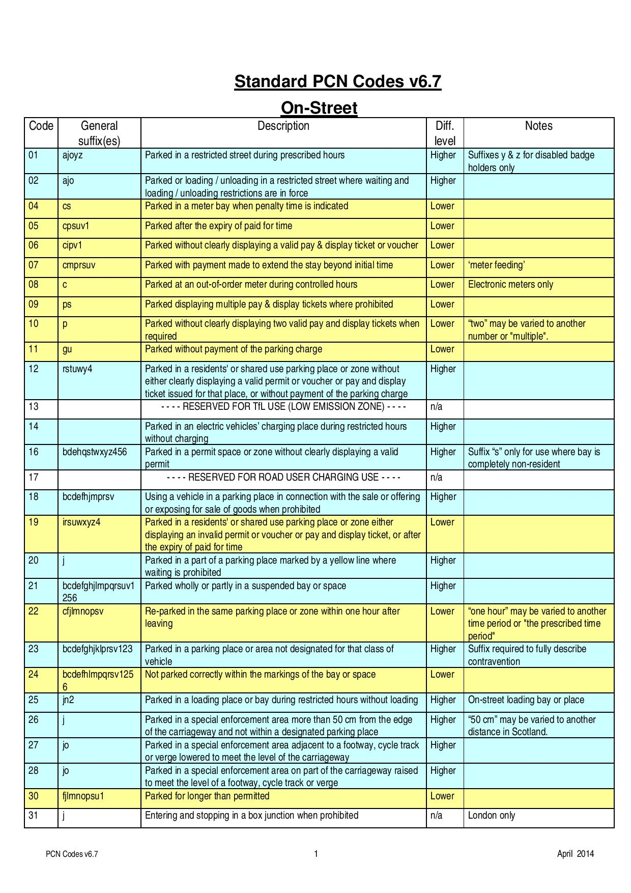
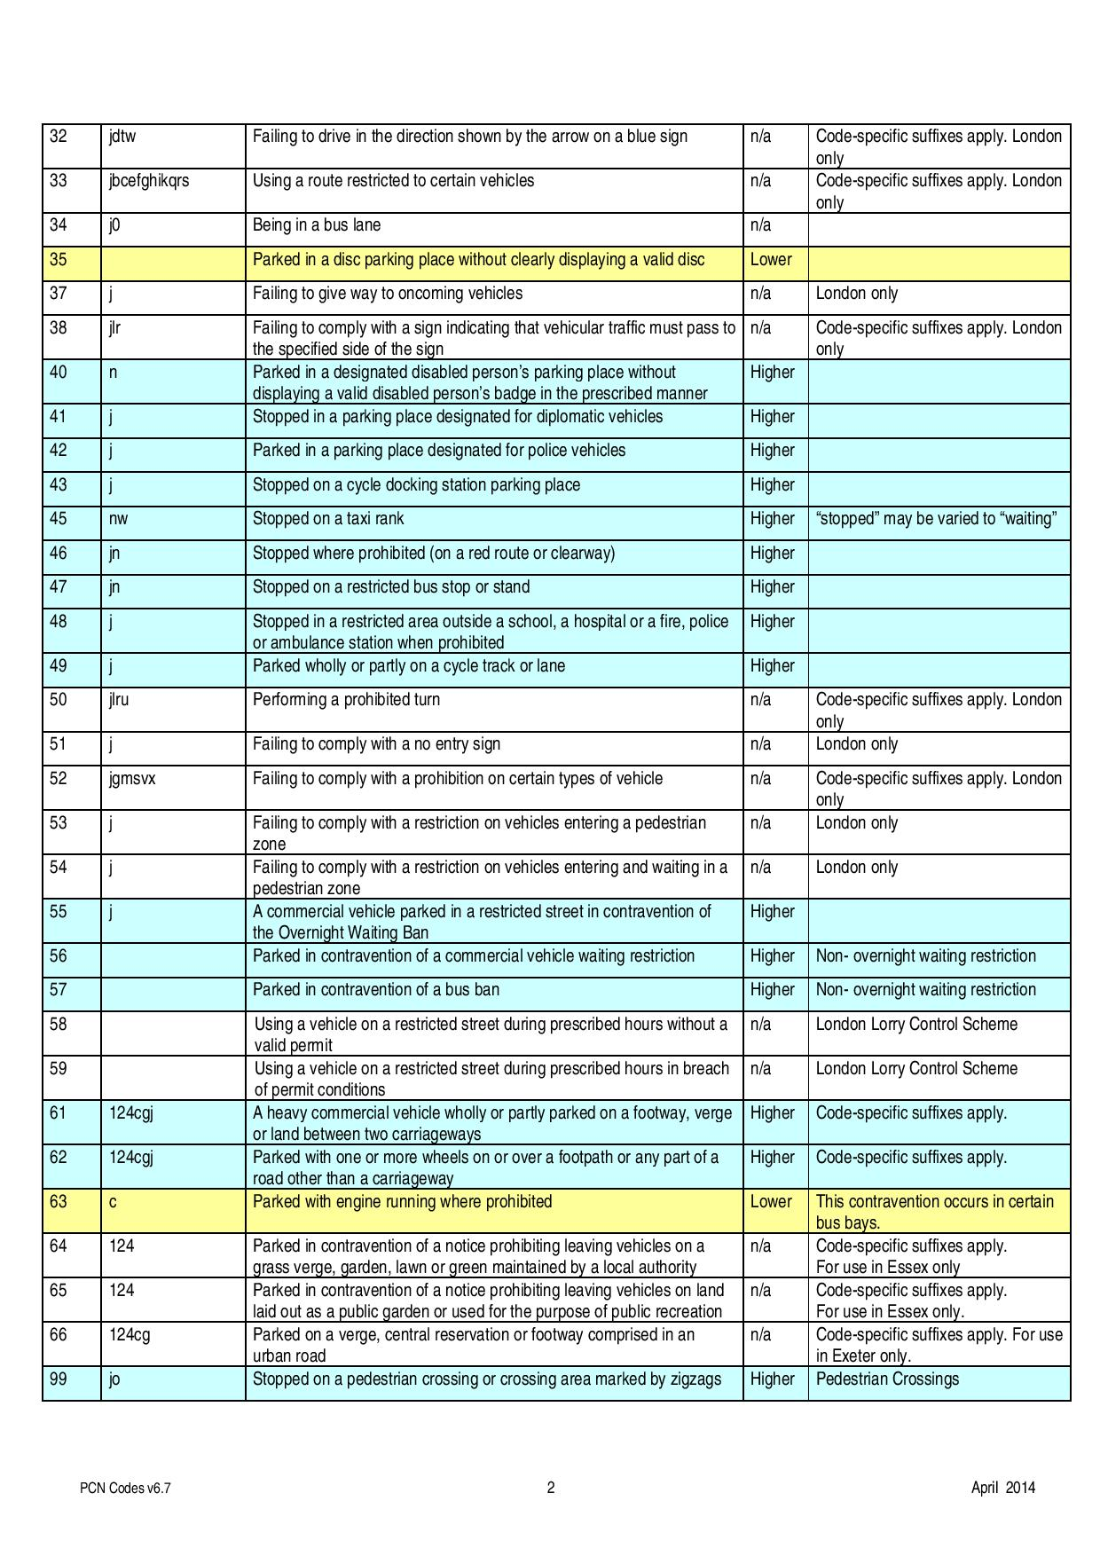

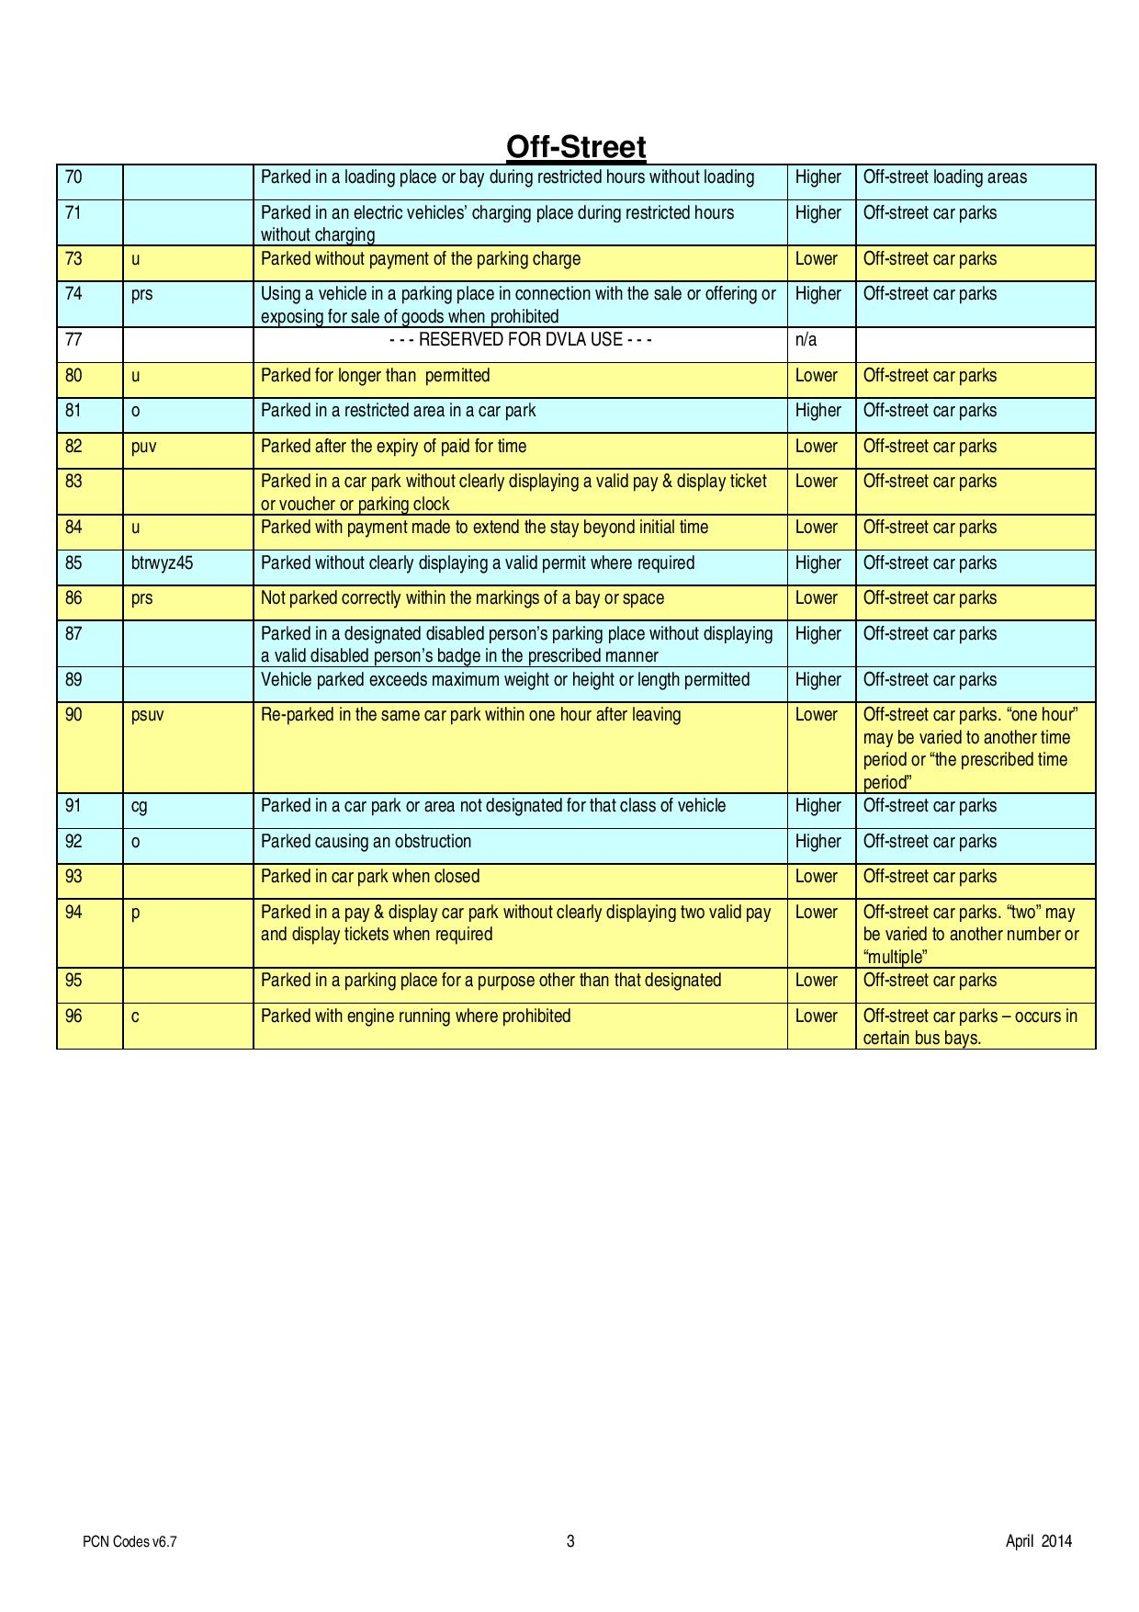

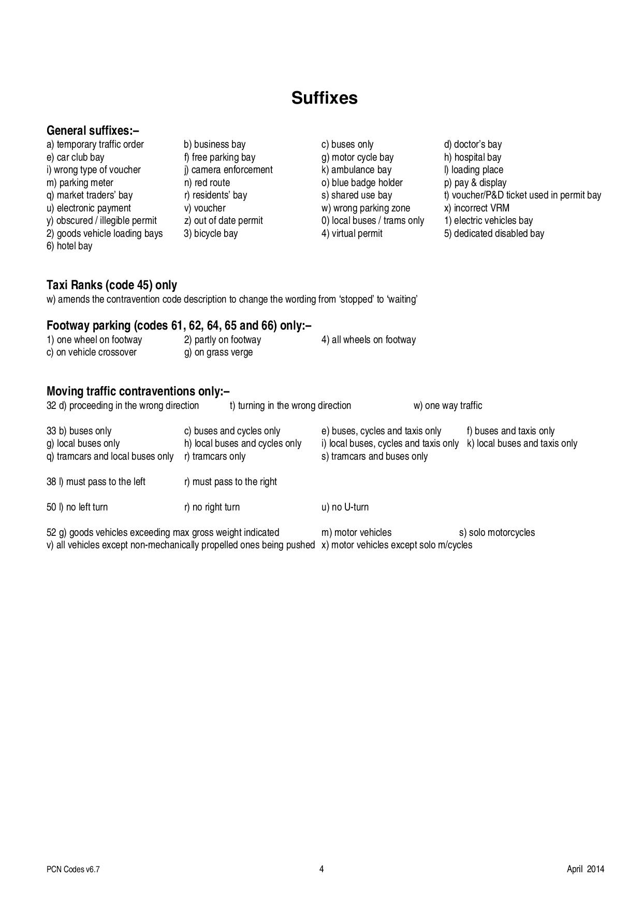

Dated: 2021

EXECUTED AS A DEED )
by affixing the common seal of )
MANSFIELD DISTRICT COUNCIL )
hereto affixed in the presence of:- )

Monitoring Officer & Head of Law and Governance

(*delete as applicable)

Chief Executive / Strategic Director / Head of Finance

(*delete as applicable)

